Faculty of Data Sciences

Ghulam Ishaq Khan Institute of Engineering Sciences and Technology, Topi

CS311L- Operating System Lab

Fall 2024

Lab No : 02

Lab Title : OS

Student Name : Muhammad Bilal

Registration No : 2022360

Submission Date : 1st October

Submitted To : Ms. Mah Rukh

Task 1:

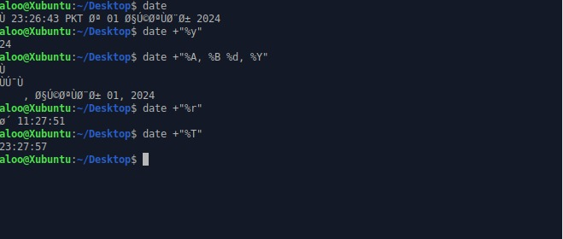

Task 2 + 3:

Task 4:

